The Effects of Social Media Use on Mental Health
Your name, advisors’ name, names of any other collaborators Name of department, Dartmouth College
Funding source (you can either put this info here or down towards the bottom in an “acknowledgements” section)

INTRODUCTION
Social media can be defined as interactive technologies that are used for the sharing of information, interests, ideas as well as other forms of expression through networks and virtual communities. Technological advancements and developments of the internet of the past couple of years have enhanced connection and sharing of information. Social media has however, enhanced connection. Many people in the world today have access to electronic devices that use social media networks alerting them of global events and updates on friends. Statistics show that more than 56% of the world’s population use social media. Social media is an important communication tool that has changed how humanity interacts. Despite its benefits in enhancing communication, reliance on it has negative consequences on the mental health of users.
Title of the Research Project
Your name, advisors’ name, names of any other collaborators Name of department, Dartmouth College
Funding source (you can either put this info here or down towards the bottom in an “acknowledgements”section)

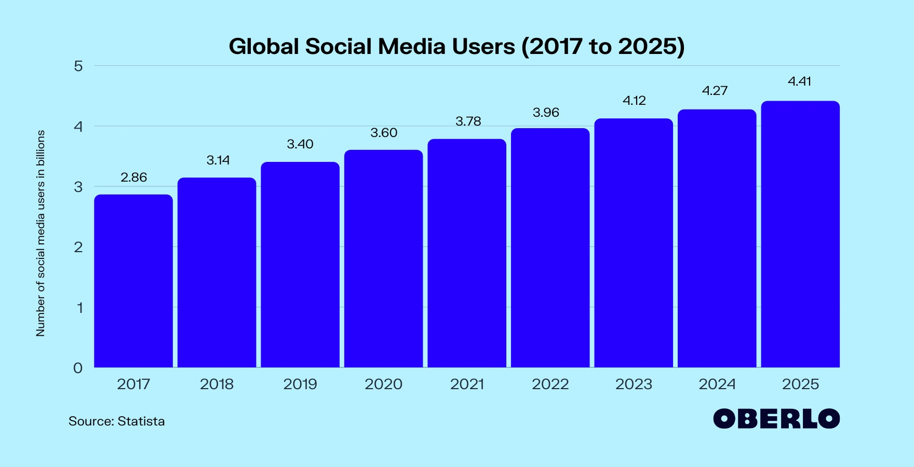

ROLE ON MENTAL HEALTH EFFECTS
People are social creatures that require companionship from others to succeed in life. The strength of this connection to other people has a significant impact on their mental health. Social connections to other people can ease anxiety, depression, stress, prevent loneliness, and boost self-worth. Lack of social connections on the other hand can be a challenge for mental and emotional health.
While social media platforms such as Facebook, Instagram, Twitter, YouTube and Snapchat have it benefits in connecting people and sharing information and ideas, they cannot replace real-world human connection.
Social media can harm mental health as it is associated with anxiety, depression, low quality sleep, and low self-esteem.
Studies show that people who spend more time on social media are more likely to have to be affected by mental health issues such as anxiety, low self-esteem and depression than occasional users (Berryman, Ferguson & Negy,2018).
CONCLUSION

Social media plays an important role in connecting people, sharing ideas, experiences and information. Their use however has been associated to negative consequences on mental health including anxiety, depression, fear of missing out, and isolation. It is a critical aspect that needs to be addressed to avoid negative consequences and achieve positive health outcomes.
Whereas social media do not provide the same psychological benefits as those achieved through real-world or face to face human interaction, there are still positive aspects connected to these platforms (Booth,2020).
Social media enables people to;
- Socialize and network.
- Help seek or offer emotional support during challenging times.
- Provides a platform for self-expression and creativity.
The negative effects include;
- Triggering feeling of inadequacy about appearance or life.
- Anxiety and depression
- Fear of missing out.
- Self-absorption
- Cyber bulling

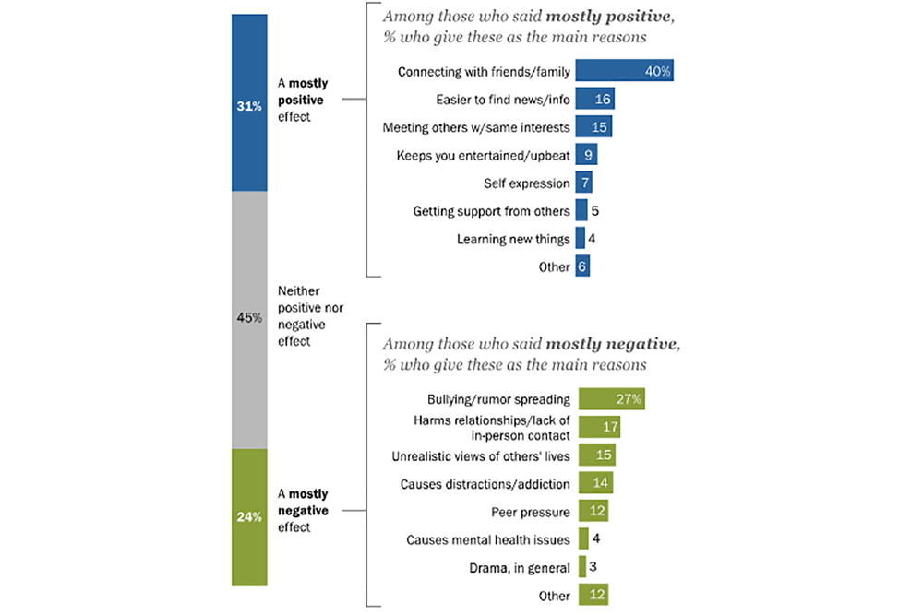

References
Berryman, C., Ferguson, C. J., &Negy, C. (2018). Social media use and mental health among young adults. Psychiatric quarterly, 89(2), 307-314.
Coyne, S. M., Rogers, A. A., Zurcher, J. D., Stockdale, L., & Booth, M. (2020). Does time spent using social media impact mental health?: An eight year longitudinal study. Computers in Human Behavior, 104, 106160.

